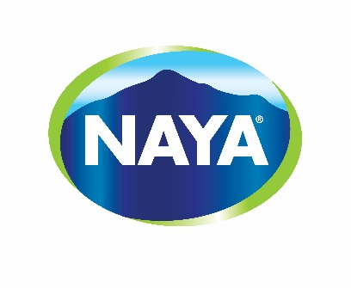 | SPONSORSHIP REQUEST FORM

Thank you for thinking of Naya as a partner!

Through the events we sponsor, we want to convey the values ​​we hold dear, such as
healthy lifestyle habits and respect for the environment.

Please note Naya’s sponsorship policy does not allow money sponsorship or donation. We can only offer product sponsorships.

Organisation Identification
Name of your organisation
Address
City
Postal Code | Province
E-mail | Phone

Contact Information
Contact Name
Title
Name of Charity or Organisation
E-mail | Phone

Event / Project / Activity
Please describe your event / project / activity

Since when has your event / project / activity existed?
Where will the event / project / activity take place?
Date of your event / project / activity
Please specify the amount of spectators that are expected to attend
How geographically visible is your event / project / activity?
- International☐
- National ☐
- Provincial ☐
- Local ☐
How many bottles are needed for the event / project / activity?
- Format
- Quantity
How do you plan to distribute the Naya products?
- Samples participants ☐
- Consumption by members of the organization ☐
- Resale ☐
Is there a recycling system provided on the event site?
- Yes☐
- No☐
Specify
Cliquez ici pour taper du texte.
What would be the visibility associated with this sponsorship?

Thank you for taking the time to complete this document. Please send the request by email to the following e-mail address: commandite@naya.com. Our team will take the time to study your request and get back to you within two weeks.
Sincerely,
The Naya Waters Team

